Breaking Bad Database-Tables

User_table

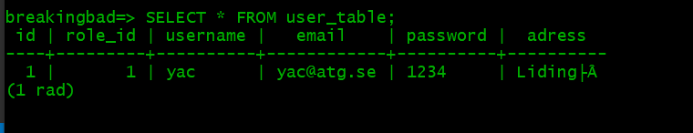

Role_table

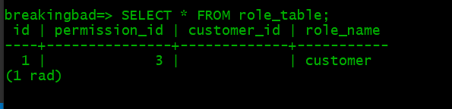

Permission_table

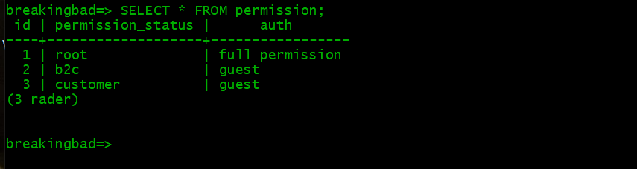

Customer_table

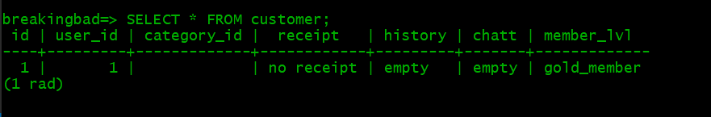

Join_table

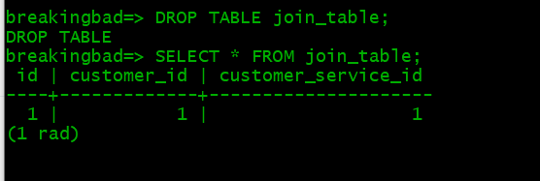

Customer_service_table

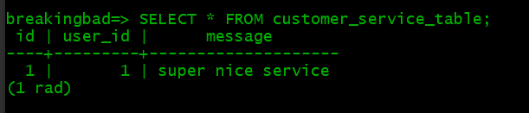

Community_table

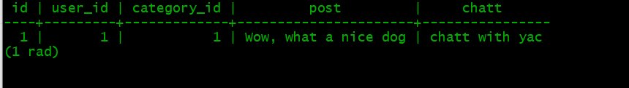

Category_table

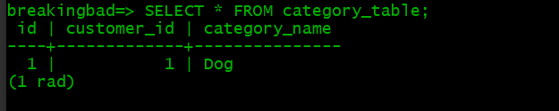

Member_benefits_table

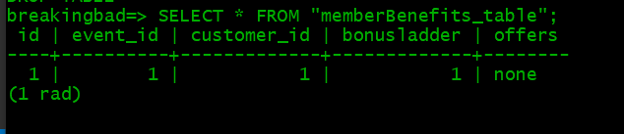

Event_table

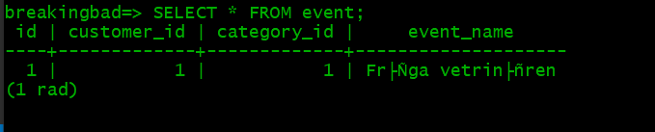

Customer_service_ticket_table

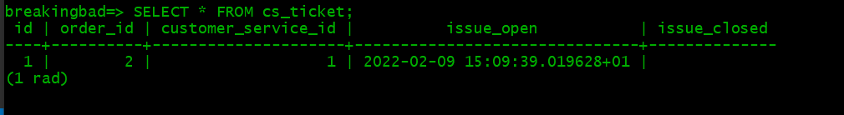

Order_table

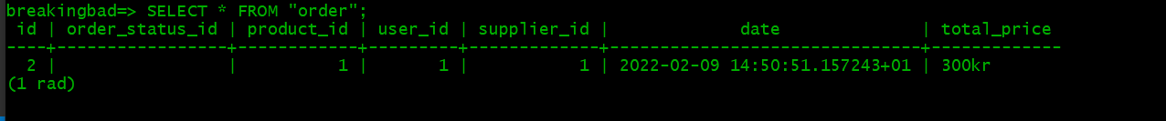

Order_status_table



Supplier_table

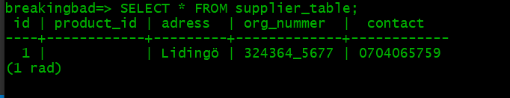

Product_table

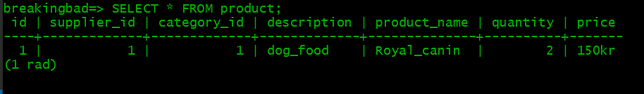

Recommendations_table

